SQL Assigment-1

Date-3/2/23

CREATE DATABASE Northwind;

CREATE TABLE Products(

ProductID int NOT NULL PRIMARY KEY,

ProductName VARCHAR(40) NOT NULL,

SupplierID int NOT NULL,

CategoryID int NOT NULL,

QuantityPerUnit varchar(20) NOT NULL,

UnitPrice DECIMAL(10,4) NOT NULL,

UnitsInStock SMALLINT NOT NULL,

UnitsOnOrder SMALLINT NOT NULL,

ReorderLevel SMALLINT NOT NULL,

Discontinued BIT NOT NULL

)

SELECT \* FROM Products

INSERT into Products VALUES (1, 'Chai', '1' , '1', '50 cups' ,'10' ,'35' ,'5', '10' ,'0')

INSERT into Products VALUES (2, 'Coffee', '1' , '1', '42 cups' ,'15' ,'12' ,'0', '25' ,'0')

INSERT into Products VALUES (3, 'Green Tea', '1' , '2', '20 Packets' ,'18' ,'15' ,'2', '0' ,'0')

INSERT into Products VALUES (4, 'Vanilla Icecream', '2' , '2', '30 boxes' ,'20' ,'12' ,'5', '10' ,'0')

INSERT into Products VALUES (5, 'Candy', '2' , '2', '50 boxes' ,'18' ,'10' ,'0', '35' ,'0')

INSERT into Products VALUES (6, 'Cone', '2' , '2', '20 boxes' ,'25' ,'17' ,'40', '30' ,'0')

INSERT into Products VALUES (7, 'white Pasta', '3' , '2', '10 packets' ,'35' ,'8' ,'0', '0' ,'1')

INSERT into Products VALUES (8, 'Maggie', '3' , '6', '50 packets' ,'19' ,'10' ,'0', '30' ,'0')

INSERT into Products VALUES (9, 'Wheat Flour', '4' , '9', '10 packets' ,'80' ,'3' ,'6', '5' ,'0')

INSERT into Products VALUES (10, 'Sugar', '4' , '7', '5 Packets' ,'60' ,'10' ,'0', '10' ,'0')

INSERT into Products VALUES (11, 'Potato', '5' , '6', '20 kg' ,'18.5' ,'15' ,'10', '5' ,'0')

INSERT into Products VALUES (12, 'Toffee', '6' , '2', '100 oz' ,'0.5' ,'3' ,'0', '0' ,'1')

INSERT into Products VALUES (13, 'Syrup', '7' , '5', '12 bottles' ,'39.99' ,'2' ,'0', '10' ,'0')

INSERT into Products VALUES (14, 'Energy Drink', '7' , '5', '20 bottles' ,'89.99' ,'0' ,'0', '0' ,'0')

INSERT into Products VALUES (15, 'Soft Drink', '7' , '2', '15 bottles' ,'19.99' ,'19' ,'0', '10' ,'0')

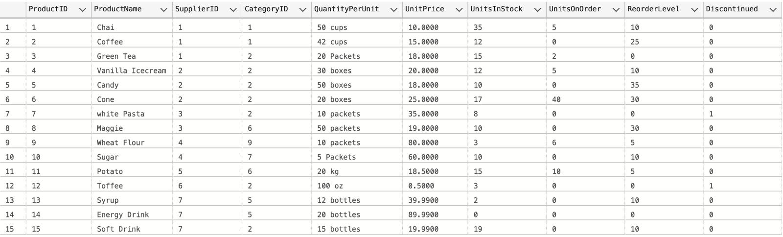

--1. Write a query to get a Product list (id, name, unit price) where current products cost less than $20.

select ProductID, ProductName,UnitPrice from Products where ((UnitPrice < 20) AND Discontinued = 0 )

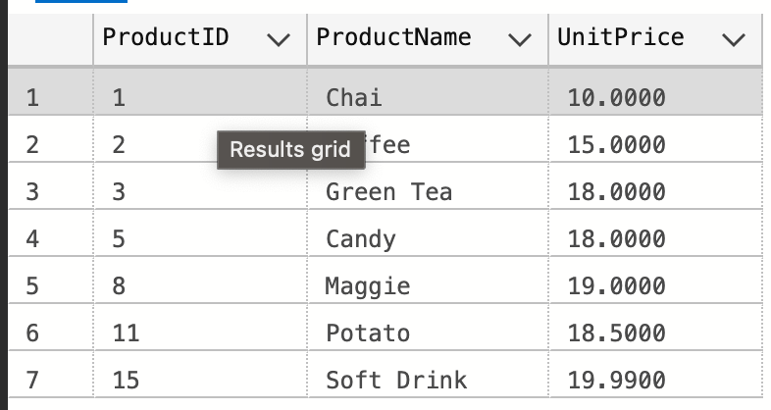

--2. Write a query to get Product list (id, name, unit price) where products cost between $15 and $25

select ProductID, ProductName,UnitPrice from Products where UnitPrice between 15 and 25

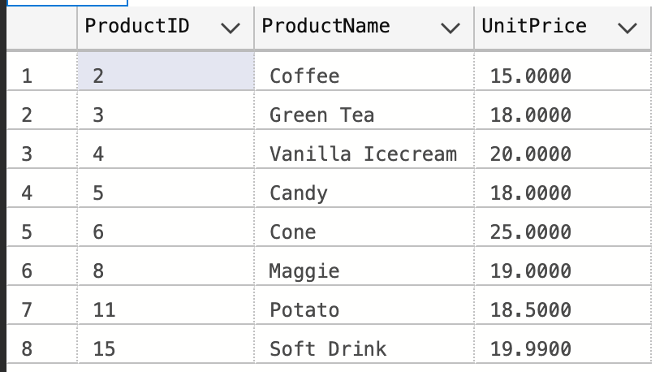

--3. Write a query to get Product list (name, unit price) of above average price.

SELECT distinct productName , UnitPrice FROM Products

where UnitPrice> (select AVG(UnitPrice) FROM Products)

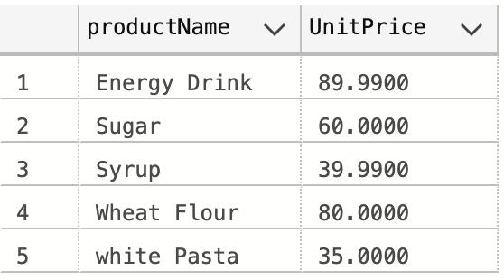

--4. Write a query to get Product list (name, unit price) of ten most expensive products

SELECT top 10 ProductName , unitprice from Products order by UnitPrice desc

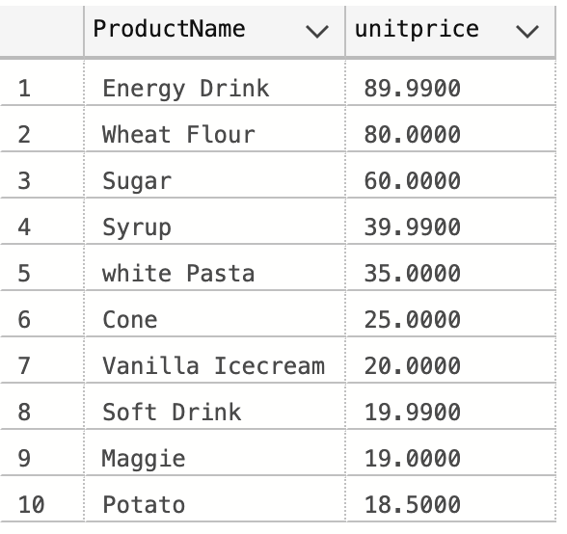

--5. Write a query to count current and discontinued products

select count(productName) from Products group by Discontinued

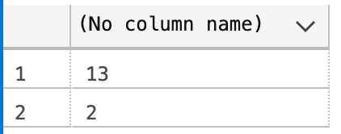

--6. Write a query to get Product list (name, units on order , units in stock) of stock is less than the quantity on order

select ProductName,UnitsOnOrder,UnitsInStock from Products where UnitsInStock < UnitsOnOrder

